|  |  |  |  |
| --- | --- | --- | --- |
| 1 | | 1,612.7142857142858 | |
| NUMERO DE FRONTERAS | | ENERGIA AGREGADA | |
|  | | | |
| NO | | 0 | |
| CONTRATO | | VENCIMIENTO CONTRATO | |
|  | | | |
| 1,638,113 | 36 | | 65,126 |
| INGRESO 2019 | DÍAS CERTIFICADOS 2019 | | ENERGIA RESPALDADA 2019 |
|  | | | |
| 586,841 | 13 | | 21,332 |
| INGRESO 2020 | DÍAS CERTIFICADOS 2020 | | ENERGIA RESPALDADA 2020 |

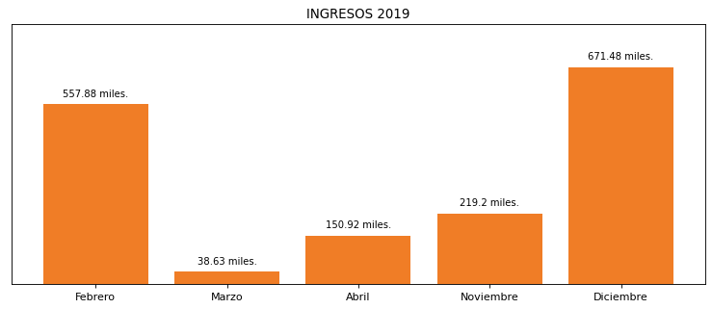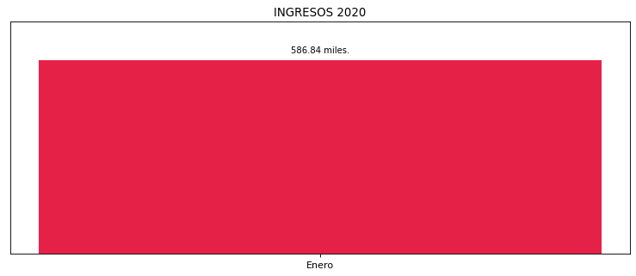

|  |
| --- |
| **HAMPTON CALI**  USUARIO |

|  |
| --- |
| **Mateo Porras**  Ejecutivo de cuenta |

|  |
| --- |
| **Julian Avila / Director de Gestión de Activos / javila@metro-op.com**  Primera fecha: PUNTO FOCAL |

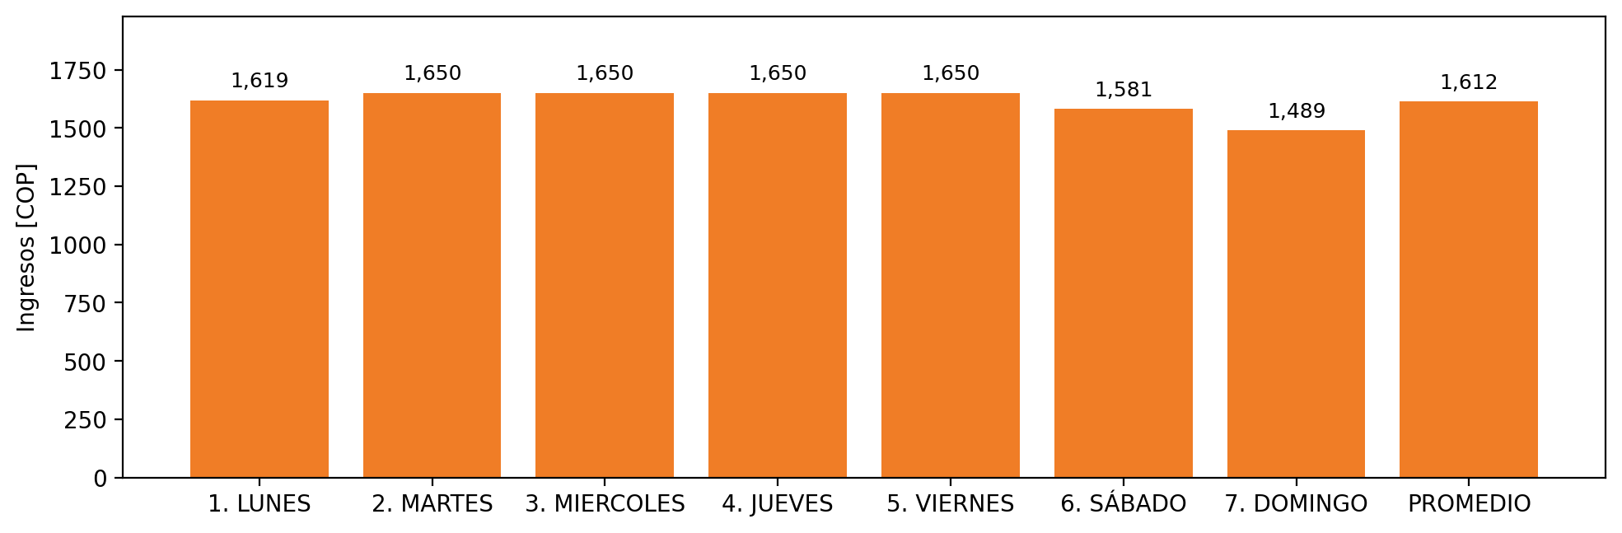

|  |  |  |  |  |  |  |  |  |  |
| --- | --- | --- | --- | --- | --- | --- | --- | --- | --- |
| **FRONTERA COMERCIAL** | **TIPO DDV** | **COD SIC** | **PREDIO** | **PROMEDIO** | **MARGEN** | **ÚLTIMA DESCONEXION** | **DÍAS CERTIFICADOS** | **ACTUALIZACION** | **PROXIMA PRUEBA DDV** |
| HOTEL HAMPTON BY HILTON CALI | Frt30008 | Frt29124 | Prd00582 | 1,612 | 4,31 | 2018-10-19 | 30.0 | 2021-11-25 | 2021-11-30 |